GitHub Storyboard Setup and Usage

# Create

1. Log into GitHub with your account.
2. Create a new repository for your project called **Team *N* TCSS 450**. For your project, please use the repository that hosts your Android client code base. Navigate to the repositories “home” page.
3. Select the Projects tab.
4. Click **Create new** project. Give your project board a name. For your project, please use the name Storyboard. Writing a description is optional. Select the **Kanban (Basic)** template. Click **Create project**.

# Setup and organization

1. Click the … on the three cards in the “To do” column. Select **Delete note**.
2. Click **+ Add column**. For the Column name, put Backlog. Preset: None. Click **Create column**. Drag the newly created “Backlog” Column to the far left.
3. Click **+ Add column**. For the Column name, put Ready for QA. Preset: None. Click **Create column**. Drag the newly created “Ready for QA” column between the “In Progress” and “Done” columns.
4. We will use labels to visually display the types of cards. To manage the labels, you will need to create an issue. In backlog, click + to add a new note. Give it any name then click add. On the newly created note, click the … and select “Convert to Issue.” Next click the issue name. This will navigate to a new page. On the right-hand column, click “Labels -> Edit labels.” Edit your labels so that they match the screen shot below. Keep the same colors. Once you have the labels created, you may delete or reuse the issue.

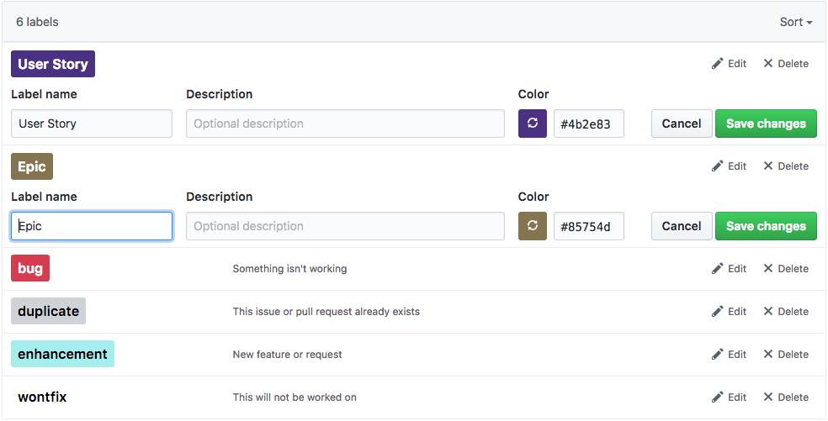

# Create a new Epic

1. In backlog, click + to add a new note. In the textbox “Enter a note” add: **Architecture Diagramming/Documentation (Arch diag/doc)**
2. On the newly created note, click the … and select “Convert to Issue.” In the dialog, add the following to the Body section:

**Epic Statement:  
As the instructor, I need to view all of architecture diagrams and documentation so that I can verify that your project structure is reasonable.**

**Acceptance Criteria:**

**-the instructor has the ability to view a UI page structure diagram  
-the instructor has the ability to view documentation describing the UI theme, to include colors, UI component styles, navigation components.**

1. Click “Convert to Issue.”
2. Next click the issue name. This will navigate to a new page. On the right-hand column, click “Labels -> Epic.”
3. Navigate back to your storyboard.

# Create a new Userstory

1. In backlog, click + to add a new note. In the textbox “Enter a note” add: **Arch diag/doc: Theme/Color documentation**
2. On the newly created note, click the … and select “Convert to Issue.” In the dialog, add the following to the Body section:

**Choose and document color schemes to use in the app. Maybe choose several and run them by the client?**

**Choose and document UI Component styles to use in the app. Maybe choose several and run them by the client?**

**Chose and document global navigation components. Maybe choose several and run them by the client?**

**Assumptions:**

**You had a discussion with the client discussing any preferences.**

1. Click “Convert to Issue.”
2. Next click the issue name. This will navigate to a new page. On the right-hand column, click “Labels -> User Story.”
3. Navigate back to your storyboard.